Enterprise SBOM Governance at Scale: Lessons from AI & Automotive
By Devashri Datta

Context & Strategy 3
Executive Summary 3
Audience 3
Why SBOM Governance Matters Now 3
Why SBOM Governance Is Hard 3
Risk & Threat Model for SBOM Manipulation 3
Mapping to SSDF Practices 4
Aligning to Regulations & Frameworks 4
Future of SBOM Governance 4
Governance Model (Policy, Controls, and Measurement) 4
Enterprise SBOM Governance Pipeline (Policy-Driven, Automated) 4
Sample Enterprise SBOM Policy (Template) 5
Threat Model & Compensating Controls 5
Supplier Governance: Scoring & Gating 6
Impact on Procurement and Authorization Decisions 6
Evidence & Audit Packaging 6
Metrics That Prove Governance (KPIs & OKRs) 7
Maturity Model 7
Scaling Across Multi-Product Organizations 9
What Governance at Scale Really Means 9
Architecture & Operations 10
Reference Architecture: Enterprise SBOM Pipeline 10
Tools Integration Architecture 13
Evolution from Static SBOMs to Governance-Driven SBOMs 14
Differentiating AI/ML SBOMs: Supply-Chain Governance for Model-Driven Systems 15
Handling Third‑Party SBOMs 16
Minimum Required SBOM Fields 16
Operating Model & Transformation 17
Implementation Roles & Responsibilities (RACI) 17
RACI / Swimlane Diagram 18
Minimum Viable Program (90 Days) 18
Roadmap Beyond MVP: Phase 2 and Phase 3 18
Transformation: Before vs After SBOM Governance 19
Why SBOM Programs Fail 19
Pitfalls to Avoid 19
Validation, Examples, and Comparisons 20
Comparison to Public Guidance 20
References 20
Format & Delivery: Set the Enterprise Standard 20
Who Uses This Model 21
Tooling Landscape (Neutral Overview) 21

Context & Strategy

Executive Summary
Software supply-chain security has shifted from a niche concern to a core business risk. With updated U.S. guidance (e.g., draft SBOM minimum elements) and the EU Cyber Resilience Act (CRA), organizations can no longer rely on static, compliance-only SBOMs. This whitepaper presents a practical, scalable governance model grounded in real-world work with AI platforms and safety-critical automotive software that transforms SBOM from a document into a continuous, policy-driven risk signal. It covers architecture, standards, program governance, roles and responsibilities, tooling, a 90‑day MVP, a 12‑month roadmap, and metrics for proving business and security outcomes.

Audience
Security architects, platform engineering leaders, Product managers, OSS compliance owners/Legal, and policy teams responsible for secure software supply-chain governance in regulated environments.

Why SBOM Governance Matters Now
In regulated sectors such as government, automotive, and critical infrastructure, SBOM governance influences procurement, certification, and deployment. Governance-driven SBOM programs enable audit readiness, supplier trust, and continuous assurance at scale. Standards and regulations now expect machine-readable formats, integrity, licensing metadata, tool provenance, and automation.

Why SBOM Governance Is Hard
• Exploding dependency graphs across modern AI/ML and cloud-native stacks
• Fragmented SBOM formats and scanner outputs; inconsistent vendor artifacts
• Manual, point-in-time inventories that go stale quickly
• Limited provenance, signing, and integrity controls for SBOM and artifacts
• High CVE noise without exploitability context (VEX) and policy gates
• Unclear ownership across engineering, security, legal, and procurement

Risk & Threat Model for SBOM Manipulation

Potential SBOM-specific attacks:
- Tampered or spoofed SBOMs
- Integrity loss due to unverified signatures
- “Missing component” attacks
- Malicious dependencies hidden through identifier drift
- Model-weight poisoning in AI SBOMs
- Compromised vendor SBOM deliveries

Mapping to SSDF Practices
SSDF Practice | SBOM Governance Control | Evidence
PS.2.1 | SBOM generation in CI/CD | Build pipeline SBOM artifacts
PW.4.1 | VEX-enabled triage | Triage logs, VEX statements
RV.1.3 | Provenance checks | Cosign/in-toto attestations

Aligning to Regulations & Frameworks
• U.S.: follow draft CISA SBOM minimum elements; use NIST SSDF (SP 800‑218) for secure development attestation
• EU: CRA technical documentation must include machine‑readable SBOMs; main obligations apply from December 11, 2027
• DoD/DIB: expect SBOMs in C‑SCRM contexts and program approvals

Future of SBOM Governance
• AI-generated SBOMs
• Runtime SBOMs from eBPF, WASM, or SBOM++ proposals
• Predictive governance using ML
• Cloud workload SBOMs
• SBOM interoperability across global regulatory regimes
• IoT & automotive safety certification convergence

Governance Model (Policy, Controls, and Measurement)

Enterprise SBOM Governance Pipeline (Policy-Driven, Automated)
illustrates an enterprise-scale SBOM governance pipeline that transforms static SBOM artifacts into automated, policy-driven risk decisions. The model integrates ingestion, enrichment, policy enforcement, and decisioning to support secure release approvals, regulatory compliance, and audit readiness.
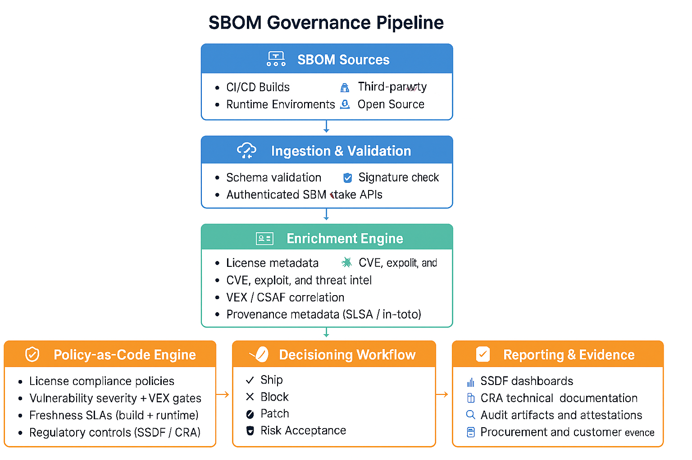

Sample Enterprise SBOM Policy (Template)
• Purpose & Scope: all released software and supplier deliverables
• Definitions: SBOM, VEX, provenance, signing, known‑unknowns
• Roles: Engineering (R), Product Security/OSPO (A), Legal/Compliance (R), Procurement (C)
• Mandatory Requirements: format (CycloneDX/SPDX), JSON serialization, schema validation, signing, coverage
• Delivery: authenticated portals/APIs; retention; customer-specific access
• Exceptions: justification, time-bound acceptance, compensating controls
• Enforcement: policy-as-code gates; blocking criteria; escalation

Threat Model & Compensating Controls
Threats
- Spoofed/forged SBOMs → verify signatures; require tool provenance
- Omitted components (“missing list” attacks) → cross-correlate SCA results + runtime SBOMs
- Identifier drift (inconsistent purl/CPE) → normalization service + deterministic matching
- Model-weight poisoning (AI) → dataset lineage, signed weights, attestation of training runs
- Compromised supplier channel → authenticated ingestion APIs; mutual TLS; audit trails
Compensation controls
- Dual data sources per release (generator + orchestrator reconciliation)
- Periodic red team SBOM audit (attempt omissions/injections)
- “No unsigned SBOM” control in release policy
- Coverage guardrail: fail gate if transitive coverage < 95% (configurable)

Supplier Governance: Scoring & Gating
Criterion | Weight | Threshold | Evidence
Format correctness (SPDX/CycloneDX JSON) | 20% | 100% valid | Schema validation logs
Signing + delivery via authenticated API | 20% | Required | Signature, API audit
Coverage (direct + transitive + known-unknowns) | 20% | ≥95% | Coverage report
Freshness (per release/patch) | 20% | SLA met | Timestamped SBOM history
VEX provided for high CVEs | 20% | ≥90% | VEX documents

Impact on Procurement and Authorization Decisions
In regulated environments, SBOM governance increasingly influences procurement eligibility, authorization to operate (ATO), and supplier trust decisions. Governance-driven SBOM programs reduce friction in these processes by providing continuous, verifiable evidence aligned with SSDF, C-SCRM, and emerging regulatory requirements

Evidence & Audit Packaging
• Build pipeline logs + signed SBOMs
• Attestation bundles (SLSA/in-toto)
• Coverage/freshness dashboards (exportable CSV/PDF)
• VEX statements + triage decisions
• Exceptions register (owner, justification, expiry)
• Supplier compliance reports + scores

Metrics That Prove Governance (KPIs & OKRs)
Operational KPIs
- % of releases with complete SBOM coverage
- MTTR for vulnerability decisioning
- % of supplier SBOMs ingested through API
- % of artifacts with verified signatures
Governance KPIs
- SLA adherence for SBOM freshness
- % of VEX statements provided for high CVEs
- % audit evidence automatically generated
Strategic KPIs
- Audit cycle time reduction
- Supplier onboarding cycle time reduction
- Change failure rate trends

Definitions & Scope Clarification
- SBOM
- Build-time SBOM vs. runtime SBOM
- VEX and CSAF
- Provenance & attestation
- Freshness SLAs
- Known-unknowns
- Supplier intake

Maturity Model
Level 1 — Consistent Generation at Build
- Organizations reliably generate SBOMs during CI/CD builds, but processes remain isolated. There is no automation beyond artifact creation, and little downstream consumption.
Level 2 — Ad Hoc SBOM
- SBOM creation becomes more common, but formats, tools, and workflows vary widely. Manual triage and manual reviews create inconsistent outcomes, resulting in gaps and scramble during audits.
Level 3 — Automated Ingestion & Policy Gates
- The SBOM pipeline integrates validation (schema, format, completeness), provenance checks, and dependency mapping. Automated policy gates enforce minimal standards, enabling block/allow decisions before release.
Level 4 — VEX-Driven Triage & Continuous Evidence
- SBOMs are enriched with VEX statements, improving vulnerability relevance and reducing noise. Dashboards track coverage, freshness, and SLA adherence, making audits faster and evidence continuous.
Level 5 — Cross-Lifecycle Correlation & Predictive Analytics
- Organizations correlate SBOM data across source, build, deploy, and runtime. Graph analytics reveal supply-chain risks, enabling predictive insights. Reporting automatically aligns to compliance regimes (CRA, SSDF).
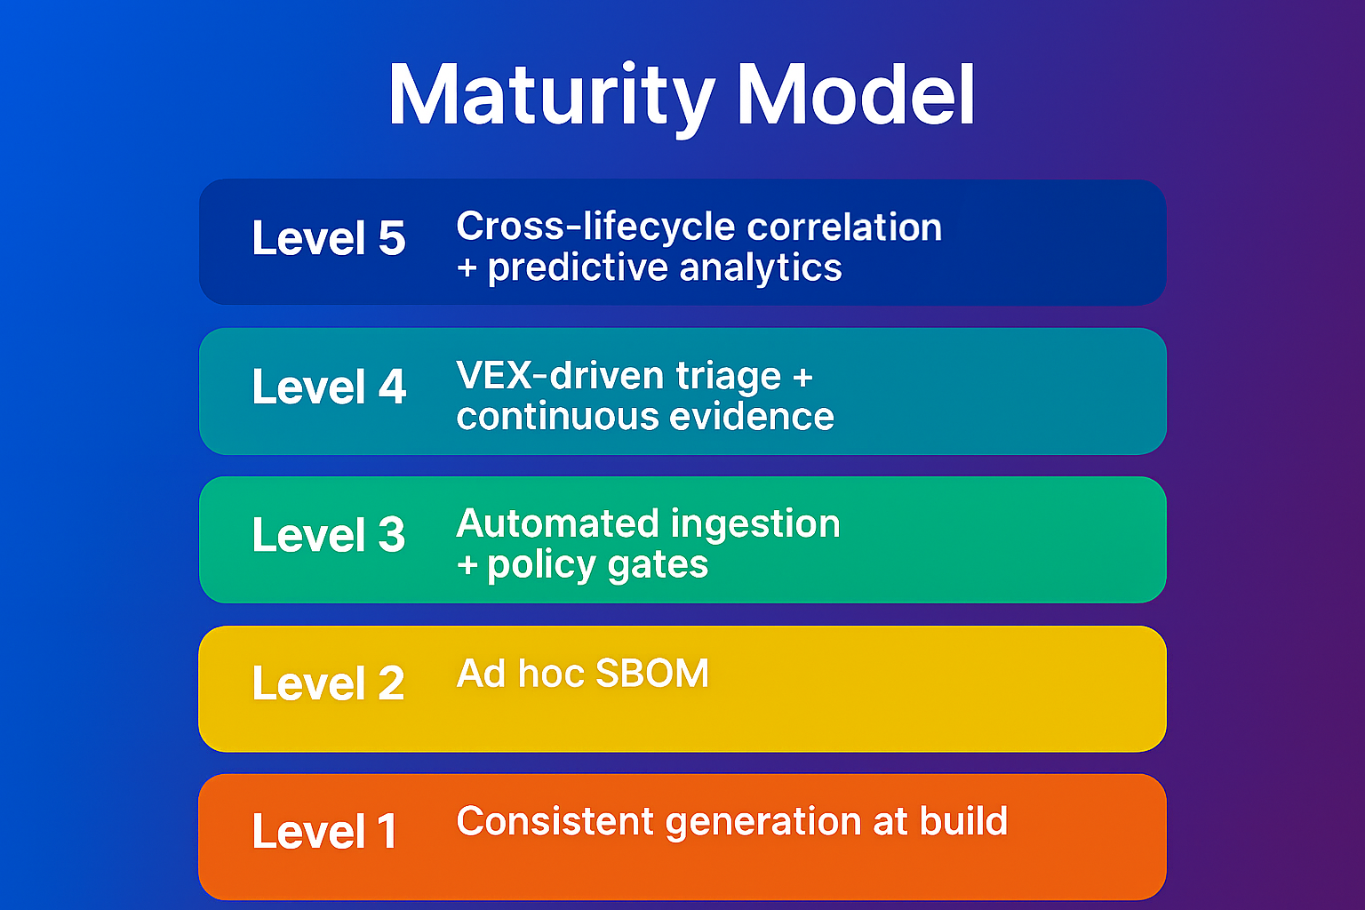

Scaling Across Multi-Product Organizations
• Different teams using different scanners
• Different formats
• Inconsistent pipelines
• Varying maturity
• Legacy products with no SBOM capability

What Governance at Scale Really Means
Treat SBOM governance as a data pipeline with policy control points and decisioning. The operating model emphasizes policy-as-code, audit-ready evidence, and lifecycle freshness across complex enterprise environments. The governance-driven SBOM operating model described in this paper reflects original implementation frameworks developed and operationalized by the author across large-scale AI and automotive software environments.
- Unlike traditional SBOM guidance, which focuses on artifact generation, this model introduces:
- Policy-as-code decisioning tied directly to release authorization
- Lifecycle-based freshness SLAs across build-time and runtime SBOMs
- Integrated exploitability-aware triage using VEX as a gating mechanism
- Audit-ready evidence mapping SBOM outputs to SSDF and regulatory controls

These design patterns represent a shift from compliance-only SBOM practices to continuous, risk-based software supply-chain governance.
- Ingestion for internal builds and supplier SBOMs
- Normalization & validation (identifiers, signatures, schemas)
- Enrichment (licenses, VEX/CSAF, vulnerabilities, provenance)
- Policy‑as‑code evaluation
- Decisioning workflows (ship, block, patch, accept, escalate)
- Reporting & audit evidence aligned with SSDF and CRA

Architecture & Operations

Reference Architecture: Enterprise SBOM Pipeline
A modern enterprise requires an SBOM pipeline that functions as a policy-driven, automated, and continuously validating system, not a one-time artifact generator. The reference architecture below outlines the end-to-end workflow—from SBOM creation to evidence generation—that enables organizations to operationalize software supply chain governance at scale.

1. Producers (Build Systems & Tooling)
The pipeline begins with SBOM producers: build systems, CI/CD pipelines, compilers, packaging tools, and third-party suppliers that generate SBOMs during the software development lifecycle.
Key responsibilities:
- Produce SBOMs in approved formats (e.g., SPDX, CycloneDX)
- Embed metadata such as component identity, versions, hashes, and dependency relationships
- Ensure reproducible and deterministic generation
This stage ensures every software artifact entering the enterprise has a verifiable provenance trail.

2. Ingestion (Identification, Normalization & Schema Validation)
Once SBOMs are produced, they enter a centralized ingestion layer.
This component performs:
- Identification: assigning internal identifiers (e.g., product, release, supplier, business unit)
- Normalization: enforcing enterprise schema requirements, rejecting malformed SBOMs
- Format coercion: mapping multiple formats into a unified internal representation
- Completeness checks: verifying minimum required SBOM fields
The ingestion stage establishes data quality, preventing downstream governance failures caused by incomplete or incorrect SBOMs.

3. Enrichment (Licenses, VEX, Vulnerabilities & Metadata)
Raw SBOMs rarely contain the full set of risk signals needed for governance.
The enrichment service augments SBOMs with:
- License data (and any associated obligations or restrictions)
- Vulnerability intelligence (CVEs, KEV listings, supplier advisories)
- VEX statements, when available, to clarify exploitability
- Component reputation and package-level trust signals
- Supplier history, including incident records or past compliance failures
Enrichment transforms SBOMs from passive inventories into actionable supply chain intelligence.

4. Policy (Governance-as-Code)
The enriched SBOM is evaluated against a policy layer implemented as code, ensuring consistent, non-negotiable enforcement.
Policies can include:
- Licensing restrictions (e.g., disallowed licenses)
- Vulnerability thresholds or severity limits
- Requirements for VEX, signature, or completeness
- Supplier trust scores or minimum gating criteria
- Internal architectural standards (e.g., validated cryptography)
A policy-as-code approach allows versioning, testing, automation, and auditability—critical for enterprise scalability.

5. Decisioning (Continuous Compliance & Release Gating)
Policy evaluation drives automated decisioning:
- Pass: Component or release meets all policy criteria
- Warn: Non-blocking issues requiring attention
- Fail: Violations that stop CI/CD pipeline progression
Decisioning creates a continuous feedback loop with engineering, security, legal, and procurement teams. This turns SBOMs into a real-time compliance gate, not a passive reporting requirement.

6. Evidence (Dashboards, Audit, Reporting & Traceability)
Every action in the pipeline produces verifiable evidence, stored centrally for audit, regulatory reporting, and cross-functional visibility.
This includes:
- Compliance dashboards
- Historical SBOM versions and policy decisions
- Supplier performance and trust scores
- Audit trails for vulnerability response
- Regulatory evidence packs (e.g., FDA, EU CRA, DoD, NIST SSDF)
Evidence enables organizations to demonstrate governance maturity, satisfy external requirements, and support business decisions around risk acceptance or supplier management.

Putting It All Together
This reference architecture represents a shift from static SBOM documents to a dynamic governance pipeline, where every SBOM is:
- validated
- enriched
- evaluated by policy-as-code
- subject to automated decisioning
- stored with complete audit evidence
The result is a robust, scalable, and defensible software supply chain governance posture that meets both enterprise security demands and regulatory expectations.

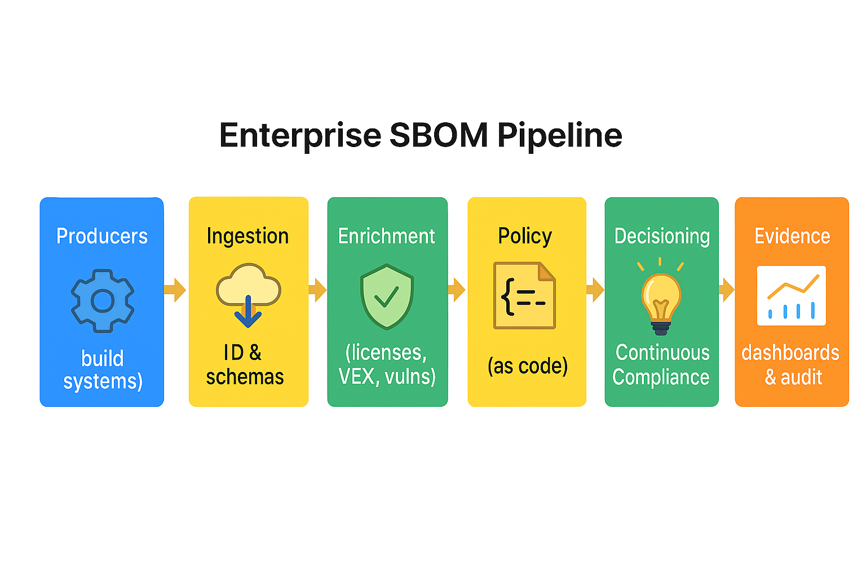

Tools Integration Architecture
Components
- CI/CD (build + release)
- SBOM generators (Syft/CycloneDX/SPDX)
- Signing/attestation (Cosign, in-toto)
- Ingestion APIs (supplier + internal)
- Normalization service (SPDX/CycloneDX, purl/CPE/SWID)
- Enrichment (SCA, CVE, VEX/CSAF, license)
- Policy-as-code engine (e.g., OPA/Rego or rule service)
- Orchestrator (Dependency-Track)
- Evidence store & dashboards (SSDF/CRA)
Rationale
- One authoritative SBOM registry per enterprise
- Immutable attestations tied to artifacts
- Event-driven gates triggered on new SBOMs or VEX updates
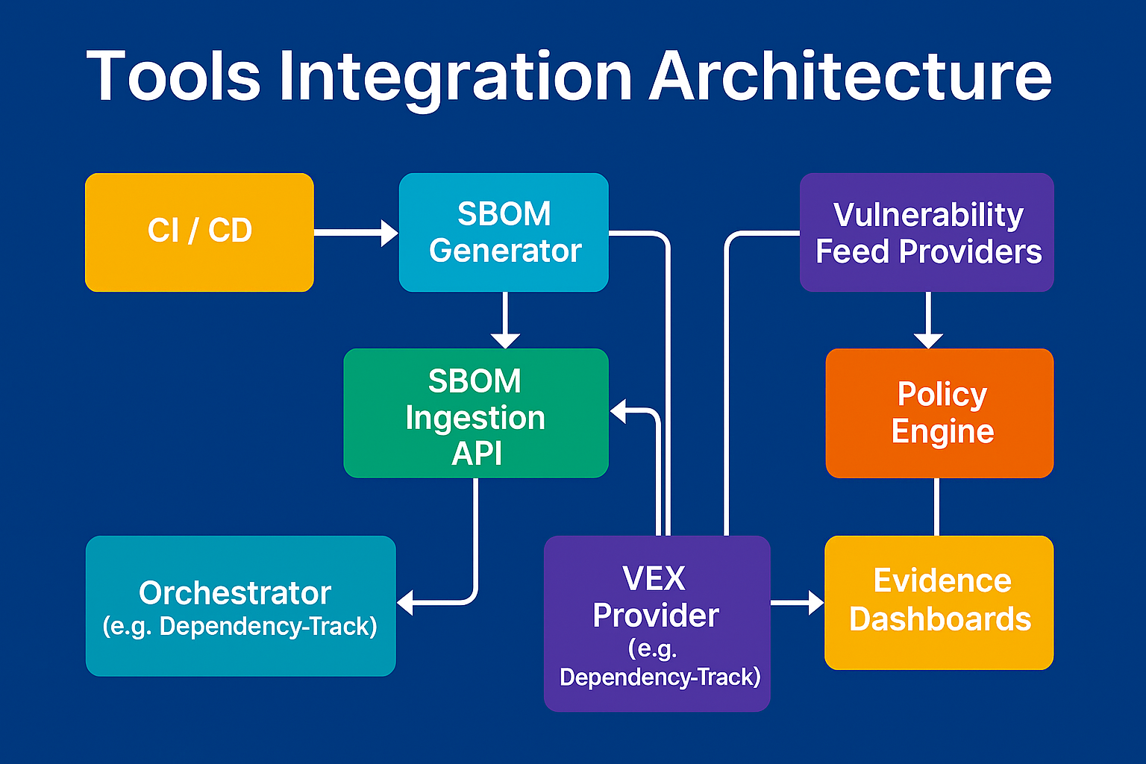

Evolution from Static SBOMs to Governance-Driven SBOMs
contrasts traditional SBOM practices focused on artifact generation with governance-driven SBOM programs that enable continuous risk assessment, automated decisioning, and regulatory evidence.
This transformation highlights the shift from compliance-only SBOM practices to continuous, decision-driven supply-chain governance.
Before (Static SBOMs):
- Manual SBOM generation
- PDF or email-based delivery
- No integrity validation
- CVE noise without exploitability context
- Reactive audit preparation
After (Governance-Driven SBOMs):
- CI/CD-integrated SBOM generation
- Signed, machine-readable artifacts
- Continuous enrichment with VEX
- Policy-as-code release gates
- Always-on audit evidence
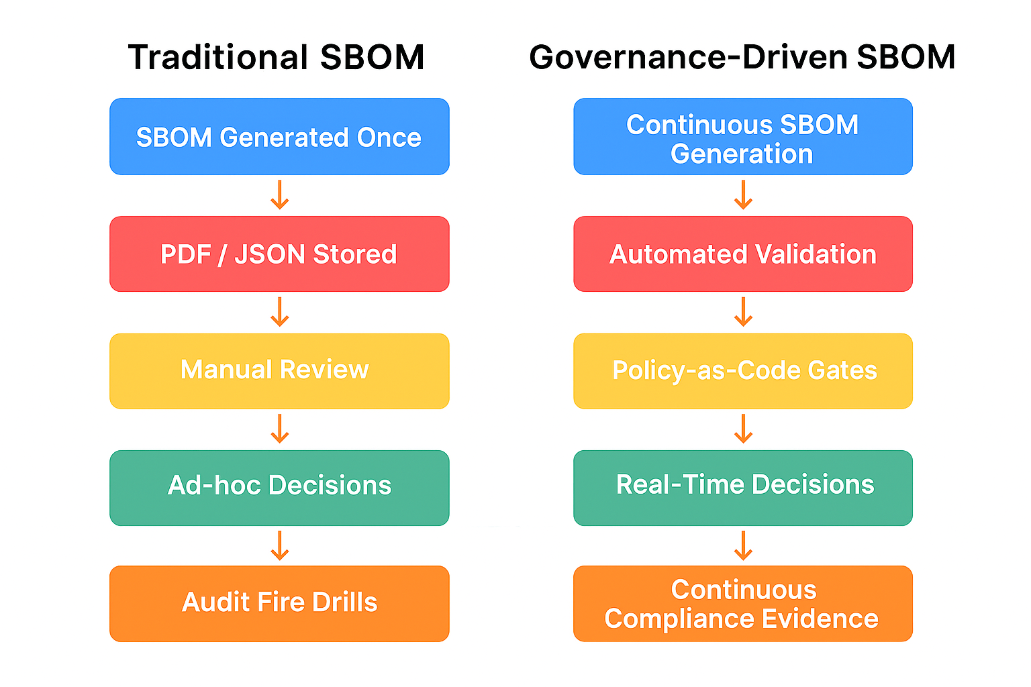

Differentiating AI/ML SBOMs: Supply-Chain Governance for Model-Driven Systems
Traditional SBOMs were designed for deterministic software binaries, where components, versions, and dependencies follow predictable build pipelines. AI/ML systems break this pattern. Their supply chains span not only code but also data, models, training pipelines, and hardware specific optimizations each introducing new provenance, integrity, and licensing risks. As AI becomes deeply integrated into safety‑critical systems (e.g., automotive ADAS stacks) and high‑assurance enterprise platforms, organizations require SBOM governance models tailored to the unique characteristics of machine‑learning software ecosystems.

Handling Third‑Party SBOMs
Expect format/version drift (SPDX 2.x/3.x; CycloneDX 1.4–1.7). Require declarations of known‑unknowns and signed, authenticated delivery. Centralize intake through APIs; validate schemas; normalize identifiers (purl/CPE/SWID).

Minimum Required SBOM Fields

To support traceability, triage, and regulatory-grade evidence, all SBOMs—whether internally generated or supplied by third parties—must include a minimal, machine-readable set of fields. These required fields ensure consistent ingestion, normalization, enrichment, and policy evaluation across the enterprise SBOM pipeline.
Required Fields
- Package Name – Canonical component identifier
- Version – Exact version or commit hash
- Recipe Name – Build recipe, manifest reference, or internal component key
- License – SPDX license identifier (e.g., MIT, Apache-2.0)
- Component Type – Library, binary, container, model, etc. (Optional but recommended)
Recommended Field
- Unique Key – Deterministic artifact identifier (e.g., SHA-256 digest, purl-derived hash, UUID) that supports traceability across releases and artifact binding.
Included as a recommendation to maintain supplier compatibility.
Confidentiality & Distribution Controls (Delivery Requirements, Not SBOM Fields)
These controls apply to SBOM exports, not the underlying SBOM schema:
- Data Classification – Applied in headers, footers, or watermarks
- Footer Information – e.g., “Prepared and provided under NDA.”
Optional Extension Fields (Customer or Regulatory Requirements)
Additional metadata may be included when explicitly required for certification, customer delivery, or contractual obligations.
These fields are intentionally minimal to preserve supplier compatibility and ensure schema validation under SPDX and CycloneDX.

Operating Model & Transformation

Implementation Roles & Responsibilities (RACI)
Activity | Engineering | Product Security/OSPO | Legal/Compliance | Procurement
SBOM generation in CI/CD | R | A/C
Schema validation & signing | R | A | C
License governance policy |  | A | R | C
Supplier SBOM intake (API) |  | A/R | C | C
VEX authoring & publishing |  | A/R | C
Exceptions & risk acceptance |  | A | R | C
Customer SBOM delivery | C | A | R | C

RACI / Swimlane Diagram
Shows how governance-driven SBOM programs distribute responsibility across engineering, security, compliance, and leadership, enabling scalable and accountable decision-making.
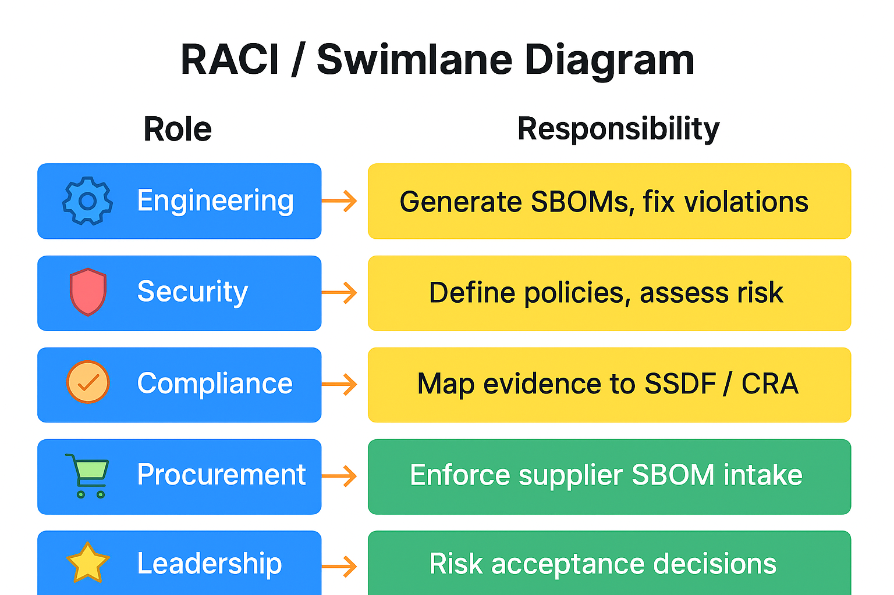

Minimum Viable Program (90 Days)
• Days 1–30: select standard (CycloneDX JSON); require signing; update supplier contracts
• Days 31–60: embed generation in CI/CD; stand up ingestion APIs; normalization; integrate VEX
• Days 61–90: enforce policy-as-code gates; build SSDF/CRA dashboards (coverage, freshness, integrity, MTTR)

Roadmap Beyond MVP: Phase 2 and Phase 3
Phase | Focus Areas | Outcomes
Phase 2 (90–180 days) | 100% CI/CD integration; license governance automation; API-based supplier intake; freshness monitoring | Reduced manual effort; faster audits; fewer release blockers
Phase 3 (180–365 days) | ML model SBOMs; multi‑stage correlation (source→build→runtime); graph analytics; enterprise dashboards | Decision-ready risk views; portfolio‑level governance; CRA/SSDF evidence automation

Transformation: Before vs After SBOM Governance
Area | Before Governance | After Governance
SBOM Generation | Manual, inconsistent | Automated, CI/CD-integrated
Coverage | Best effort | Defined SLAs; release-wide coverage
Audit Prep | Reactive evidence collection | Continuous evidence; dashboards
Third-party Intake | Email/PDF attachments | Signed, authenticated ingestion APIs
Vulnerability Triage | CVE noise; slow prioritization | VEX + policy gates; exploitability-aware

Why SBOM Programs Fail
- No lifecycle processes → stale SBOMs
- No owner for SBOM exceptions
- Gaps between build and runtime visibility
- Vendors delivering PDFs or unsigned artifacts
- Fragmented scanners creating multiple conflicting SBOMs

Pitfalls to Avoid
- Treating SBOM as a static list instead of a living data pipeline
- Ignoring license policy and obligations
- Vulnerability triage without exploitability context
- Manual vendor intake (no signatures, no APIs)

Validation, Examples, and Comparisons

Comparison to Public Guidance
This governance model builds on and operationalizes the foundational SBOM guidance published by CISA, NTIA, NIST, and OpenSSF by introducing lifecycle freshness SLAs, policy-as-code decisioning, integrated VEX gating, and audit-ready evidence designed for regulated AI and automotive software ecosystems

References
- NTIA: Minimum Elements for a Software Bill of Materials (SBOM), July 12, 2021.
- NIST SP 800‑218: Secure Software Development Framework (SSDF) v1.1, Feb 2022.
- Executive Order 14028: Improving the Nation’s Cybersecurity, May 12, 2021.
- EU Cyber Resilience Act: Regulation (EU) 2024/2847; obligations apply Dec 11, 2027.
- CISA Draft: 2025 Minimum Elements for a Software Bill of Materials (public comment).
- OWASP CycloneDX Specification (ECMA‑424); JSON and XML schemas; v1.4+.
- SPDX Specification (ISO/IEC 5962); v3.0/3.0.1 updates.
- NTIA VEX Overview: Vulnerability Exploitability eXchange (machine‑readable vulnerability status).
- OWASP Dependency‑Track: SBOM ingestion, VEX support, continuous analysis.

Format & Delivery: Set the Enterprise Standard
SBOMs must be generated in machine‑readable formats—CycloneDX (v1.4+) or SPDX—with JSON serialization. Policies should govern coverage (including declared known‑unknowns), freshness (every update/patch), integrity (signing and hash verification), and secure delivery (authenticated portals/APIs). Pair SBOMs with VEX to drive exploitability-aware triage.

Who Uses This Model
In practice, governance-driven SBOM programs reduce time-to-decision during vulnerability disclosures by replacing manual reviews with policy-driven gates, enabling faster release approvals while maintaining regulatory compliance.

Tooling Landscape (Neutral Overview)
Category | Examples | Notes
SBOM Generation | Syft; CycloneDX CLI; SPDX tools | Run at build; capture resolved versions
SCA & Vulnerability Intelligence | BlackDuck; CodeInsight; Snyk; Grype; OSS Index; GitHub Advisories | Enrich SBOM with CVEs and metadata
SBOM Orchestration | OWASP Dependency‑Track | Ingest, correlate, monitor; supports VEX
Signing/Attestation | Sigstore/Cosign; in‑toto | Bind SBOM to artifact; verify integrity
CI/CD Integration | GitHub Actions; GitLab; Jenkins | Automate generation, validation, delivery

PUBLIC DOMAIN DEDICATION (CC0 1.0)

To the extent possible under law, the author has dedicated this Software Bill of Materials (SBOM)

work to the public domain under the Creative Commons CC0 1.0 Universal dedication.

You may copy, modify, distribute, and use this SBOM, even for commercial purposes,

without asking permission.

Author: Devashri Datta

More information: https://creativecommons.org/publicdomain/zero/1.0/

